# DEEP LEARNING ANALYSIS REPORT

**Overview of the analysis**

This analysis is performed to determine the applicants for the nonprofit foundation Alphabet Soup to fund with the best chance of success in their ventures.

Using machine learning and neural networks, the features in the provided dataset are used to create a binary classifier that can predict whether applicants will be successful if funded by Alphabet Soup.

**Results**

* **Data Preprocessing**

The columns given in the dataset are

EIN and NAME—Identification columns

APPLICATION_TYPE—Alphabet Soup application type

AFFILIATION—Affiliated sector of industry

CLASSIFICATION—Government organization classification

USE_CASE—Use case for funding

ORGANIZATION—Organization type

STATUS—Active status

INCOME_AMT—Income classification

SPECIAL_CONSIDERATIONS—Special considerations for application

ASK_AMT—Funding amount requested

IS_SUCCESSFUL—Was the money used effectively

* + The target variable for the model is IS_SUCCESSFUL.
  + Features for the model are APPLICATION_TYPE, AFFILIATION, CLASSIFICATION, USE_CASE, ORGANIZATION, STATUS, INCOME_AMT, SPECIAL_CONSIDERATIONS, ASK_AMT.
  + The variables removed from the model are EIN and NAME.

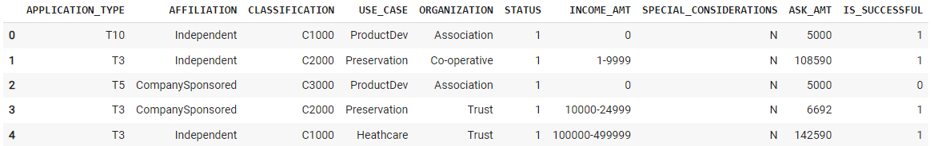

* **Compiling, Training, and Evaluating the Model**

For the initial model, 2 layers were chosen as that is usually the starting point to train a model and most complex models can usually be trained with 2 layers. The first layer had 80 neurons and the second layer had 30 neurons.

However, with this model properties, the target model performance, which was 75%, was not achieved. This model was able to have an accuracy of 73%.



This model was attempted to be optimized to achieve the target model performance. The following attempts were made.

Attempt 1:

The features INCOME_AMT, ORGANIZATION and USE_CASE were dropped from the model input. This resulted in 72.68% accuracy.

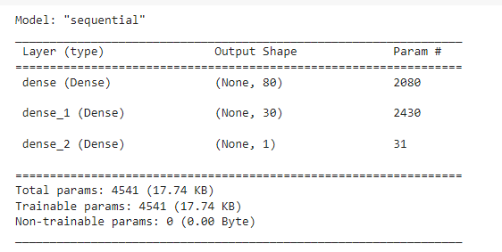

Attempt 2:

The neurons in the first layer were reduced to 8 and the neurons in the second layer were reduced to 5. This resulted in 72.4% accuracy.

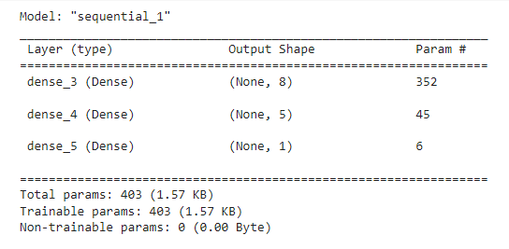

Attempt 3:

OneHotEncoder was used to transform the categorical variable list. 3 layers with 80, 30 and 10 neurons were used respectively. The epochs was increased to 200. This resulted in 72.53% accuracy.

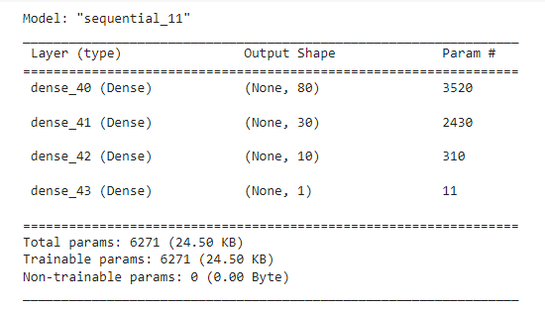

Unfortunately, with the above-mentioned attempts, the target model performance was not achieved.

**Summary**

In summary, the model designed as part of this assignment was unable to reach the target model performance. One approach to improve the performance would be to use auto optimization where we could get the appropriate number of layers and neurons to be used to get the desired results.